# CAP 4453: Robot Vision AdaBoost Assignment

**NOTE: In order to successfully complete this assignment, please read and follow the instructions very carefully. Most of the issues students experience are due to making some mistake in following the instructions. These instructions have been tested on Visual Studio 2015; you can use any other version at your own risk.**

**Download the Adaboost Software:**

1. Initially, go to https://[www.dropbox.com/](http://www.dropbox.com/) and then sign in using the following information: Email: [robot.vision.files@gmail.com](mailto:robot.vision.files@gmail.com) , and Password: robotvision in order to download the AdaBoost Software.

After the Adaboost.zip is downloaded, extract all the contents; in the rest of the notes, we will call this the **extracted folder**.

# Next, download Visual Studio:

1. **Go to the following link to download Visual Studio Community 2015.**

[How to download Visual Studio Community Edition 2015 (not 2017) - Stack Overflow](https://nam02.safelinks.protection.outlook.com/?url=https%3A%2F%2Fstackoverflow.com%2Fquestions%2F44290672%2Fhow-to-download-visual-studio-community-edition-2015-not-2017%23&data=04%7C01%7Cg.sailasya%40Knights.ucf.edu%7C9a0afc07962c48ccc0d608d9871e3245%7C5b16e18278b3412c919668342689eeb7%7C0%7C0%7C637689386027409134%7CUnknown%7CTWFpbGZsb3d8eyJWIjoiMC4wLjAwMDAiLCJQIjoiV2luMzIiLCJBTiI6Ik1haWwiLCJXVCI6Mn0%3D%7C1000&sdata=P%2BC7fkTfECBESkzBDkffAV2ORRy42I2GBbAL%2FUIjniY%3D&reserved=0)

On clicking the above link, the following page is opened.

Then you scroll about 40 lines down and click on the link that looks like the one shown in the attached screenshot to download the file.

The download will take between 20 minutes and 1 hour (depending on your network speed.)

Then you must double click on that download, and it will show you the .exe file, that you must run to do the installation.

In Visual Studio 2015, Visual C++ is not installed by default. When installing, be sure to choose Custom installation and then choose Programming Languages (click the tiny triangle that is beside Programming Languages, it will open a drop-down menu) and then choose Visual C++ from the drop-down menu.

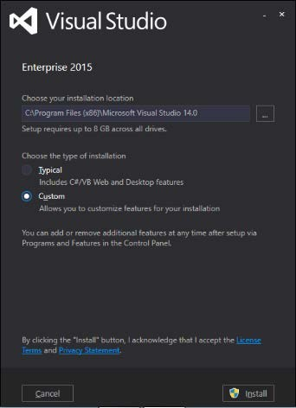

Or, if Visual Studio is already installed, choose File | New | Project | Visual C++ and you will be prompted to install the necessary components.

# Now wait until your visual studio is installed (installation can take anywhere from 60 minutes to 150 minutes). After that, you can start your assignments by following the steps below:

1. Create a directory (folder) called c:\AdaBoost.
2. The rest of the instructions assume that you are using Microsoft Visual Studio versions 6 and higher.

Create two VC++ Win32 Console projects in the following way:

Open up Visual Studio 2015; then click New Project; select Win32 Console Application; in the name field, type in vboost; in the Location field type in c:\AdaBoost\

select "Create directory for solution"; click OK. (the project name is vboost, so the directory of vboost will be generated automatically within c:\AdaBoost\ )

Re-open Visual Studio 2015 (so, a second window will open up); click New Project, and repeat the above steps to create a second project named vdetect (this second project name is vdetect, so the directory of vdetect will be generated automatically within c:\AdaBoost\ )

Both should initially be in default settings.

1. By navigating the folders, create the following 3 subdirectories in the vboost folder:-

c:\AdaBoost\vboost\vboost\classifiers, c:\AdaBoost\vboost\vboost\weights,

and c:\AdaBoost\vboost\vboost\histograms.

4.

Close all (both) projects.

Copy vboost.cpp **from the extracted folder** to the vboost project located in the C:\AdaBoost\vboost\vboost folder (replace the file in that destination).

Copy vdetect.cpp **from the extracted folder** to the vdetect project located in the C:\AdaBoost\vdetect\vdetect folder (replace the file in that destination).

5.

Open Visual Studio 2015 (again), click File; then Open; then Project/Solution; double click on the folder vboost, then double click on the file vboost (that is of type Microsoft Visual Studio Solution). This will show the vboost program.

6.

Then, in the main menu, click Project, select vboost properties, click the triangle near Configuration Properties, look under General, and Platform Toolset must say:

**v100** for VS 2010, **v110** for VS 2012, **v120** for VS 2013,

or **v140** for VS 2015 (it will say **“Visual Studio 2015 (v140)”**).

7. Navigating the folders, make sure that new.cls and new.txt do not exist in Adaboost\vboost\vboost (delete them if necessary)

8.

Copy folders positive and scenery **from the extracted folder** to C:\Adaboost\vboost

1. After opening vboost program in Step 5,.

For Visual Studio 2013 or higher, replace each stricmp with _stricmp in vboost.cpp. (There are at least 6 places that need replacement).

1. Next, we need to add **_CRT_SECURE_NO_WARNINGS**

For adding it,

Right-click on vboost in Solution Explorer, select Properties, look at Configuration Properties; click the tiny triangle near C/C++; select Preprocessor; click Preprocessor Definitions, at the end of that line click the drop-down button, and select Edit. Then paste (or type in):

# _CRT_SECURE_NO_WARNINGS

**and click OK. Then click Apply, and then OK.**

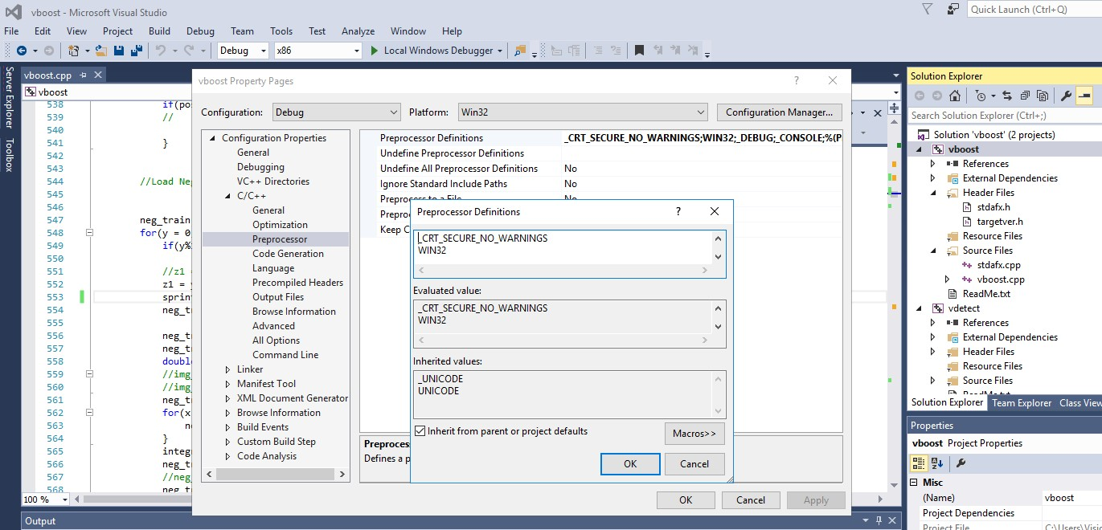

1. Then compile vboost.cpp (Main Menu -> Build -> Build Solution). Copy vboost.exe (generated after successful compilation) from C:\Adaboost\vboost\Debug\ to C:\AdaBoost\vboost\vboost.
2. In a command-line prompt window, navigate to the folder shown in the line below, and then type the boldfaced text:

C:\Adaboost\vboost\vboost> **vboost.exe new.cls 500 500 1 100**

for the program to work (this will read in 500 positive and 500 negative samples).

You can increase the number of iterations from 100 (last parameter) to more, in order to see the difference in the performance of the detector.

1. For our system (i7 processor with 16gb RAM), it took 10 mins to run 100 iterations, and then a new.cls was generated. Once new.cls is generated, terminate the code. For each 10 iterations, a classifiersiterationX.cls is generated … don’t terminate now, wait until it is finished and the file new.cls is generated.

# Note: clear .cls files in the folder when you start the training each time.

// __

Open vdetect project.

For Visual Studio 2013 or higher, replace each stricmp with _stricmp in vdetect.cpp. (Similar to Step 9).

In addition (Similar to Step 10), add **_CRT_SECURE_NO_WARNINGS** Right-click on vdetect in Solution Explorer -> Properties -> Configuration Properties -> C/C++ -> Preprocessor -> Preprocessor Definitions -> Edit ->

# _CRT_SECURE_NO_WARNINGS then OK, Apply and OK.

Then compile vdetect.cpp (Main Menu -> Build -> Build Solution).

1. Copy new.cls from the vboost folder to c:\AdaBoost\vdetect\Debug
2. Now, copy the Germany.pgm file **from the extracted folder** to the c:\AdaBoost\vdetect\debug folder

[optional] Download any other group photographs in PGM format to the c:\AdaBoost\vdetect\debug folder

1. Run the detector program on each of the PGM files in Command Prompt: vdetect.exe -i new.cls <photo name.pgm>

For example:

C:\Adaboost\vdetect\Debug> **vdetect.exe -i new.cls Germany.pgm**

The following output will be produced:

1. scale.pgm

a scaled version of your image.

1. detected.pgm

a file showing detection results.

(This program has an infinite loop and it is necessary to terminate the prompt window)

1. The following parameters affect performance of your detection:
2. vdetect.cpp line 894,

classifier.thresh = 0.62

try to experiment with threshold values from 0.4 to 0.8 and observe the results.

1. vdetect.cpp line 416, double scale = 1.1;

try to experiment with scale values from 0.8 to 1.4 and observe the results.

1. Finally, run the whole experiment doing training using 2000 positive images and 2000 negative images. This will take a (much) longer duration to train. Continue till Step 17, and show the result on Germany.pgm.

# Best Regards.